# FIAB Box-Folding Manual

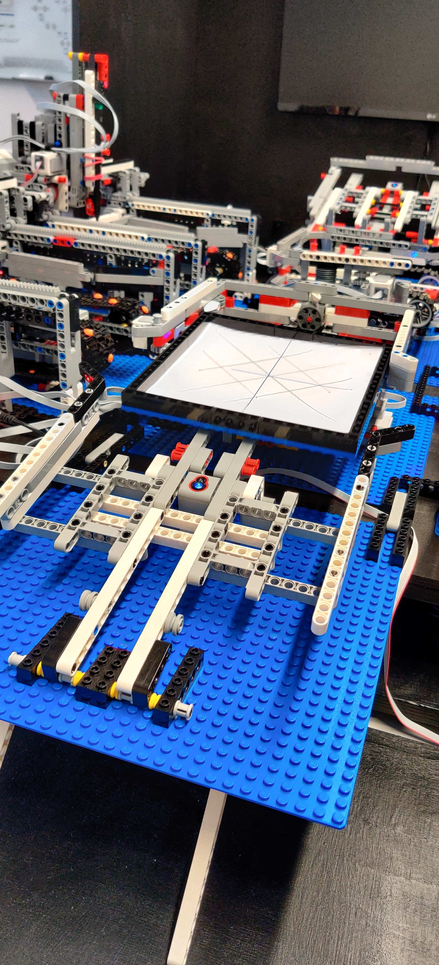

First determine which colors you want for each step

For this manual the steps are colored in the following order:

1. Black
2. Blue
3. Green
4. Red

The plotters will draw the required lines for you, when

it is finished, you will receive a pallet at the output station.

Remove the sheet from the Factory and find a comfortable

desk to fold your paper box.

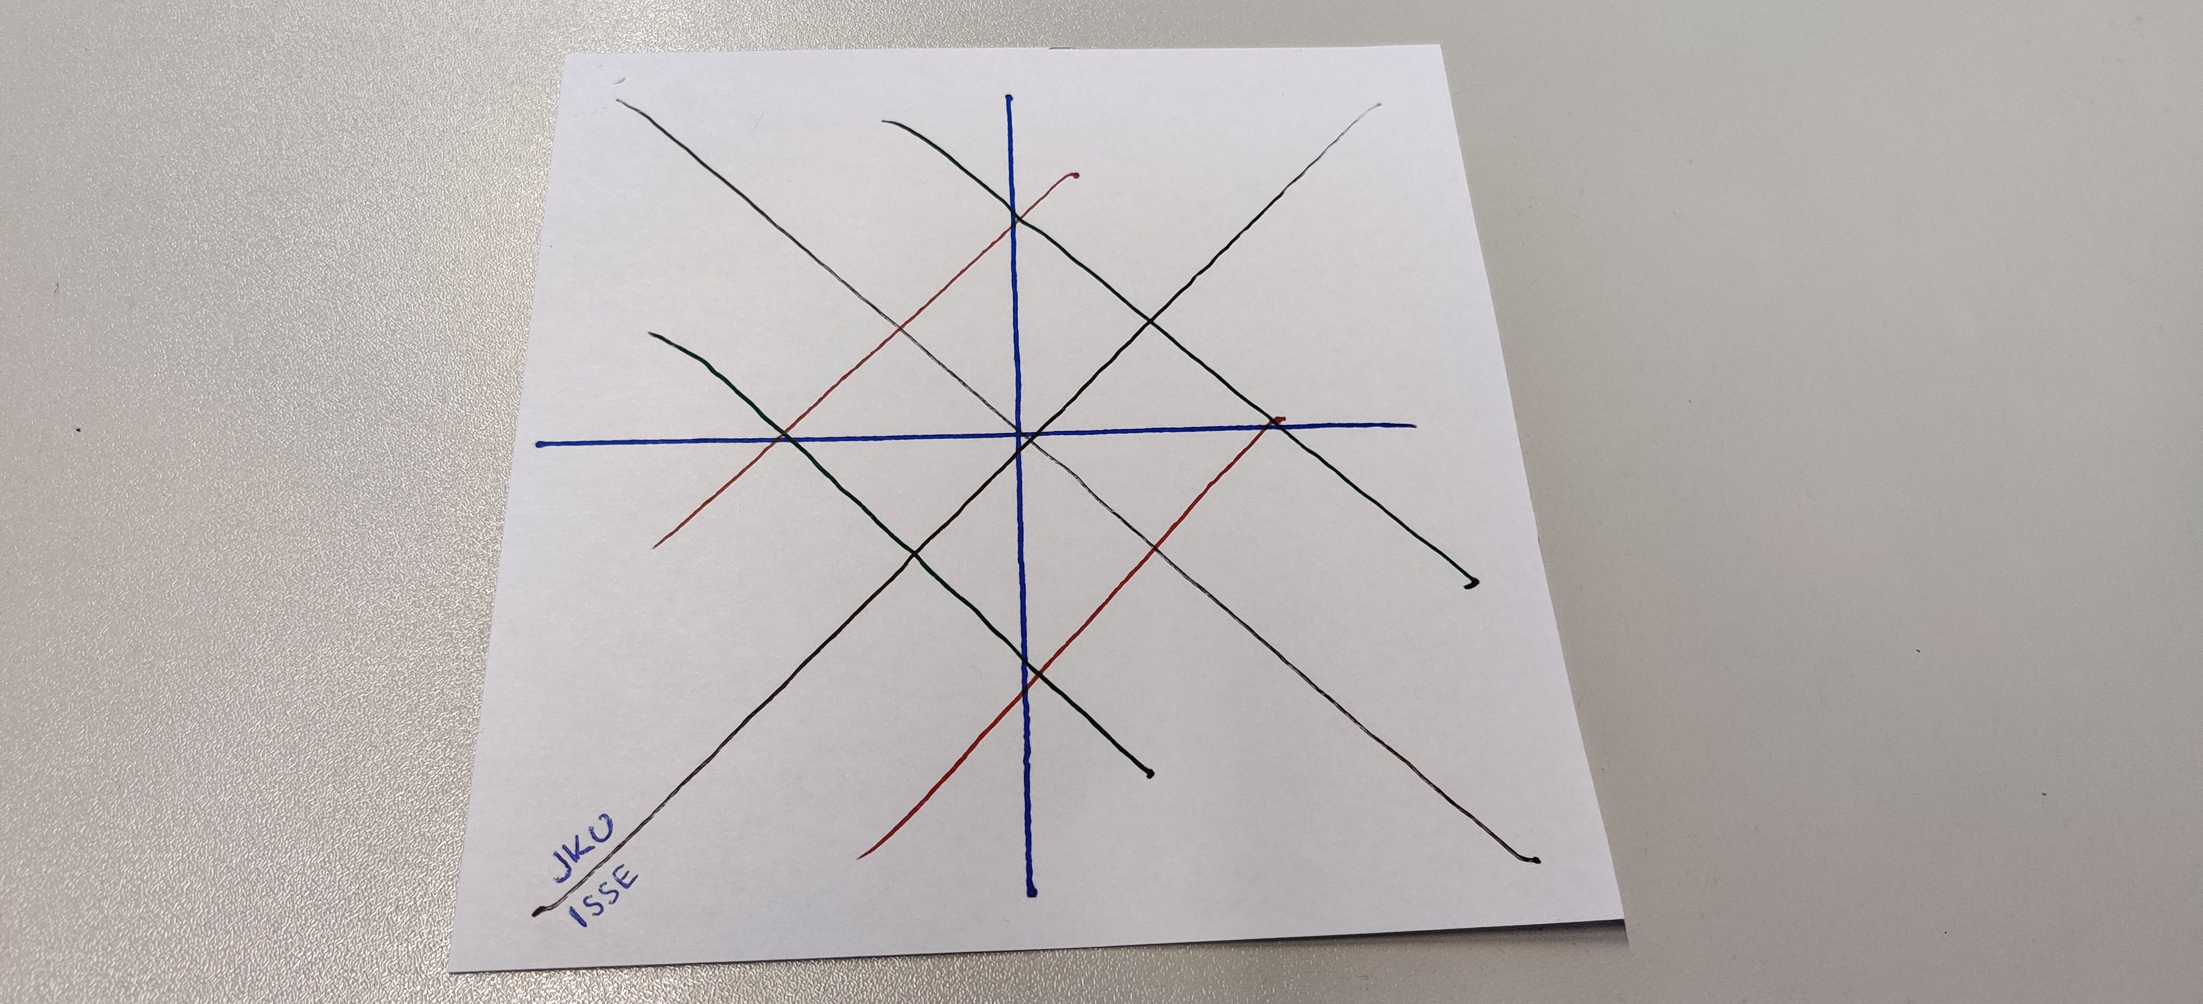

The sheet will have lines similar to this, depending on the colors you choose. Make sure the lines are facing your way.

## STEP 1

Fold the box along the first color you choose (X-Pattern), then fold it back and repeat the step for the second line in that color. In this case the color black was chosen. Then open the sheet to it’s original position.

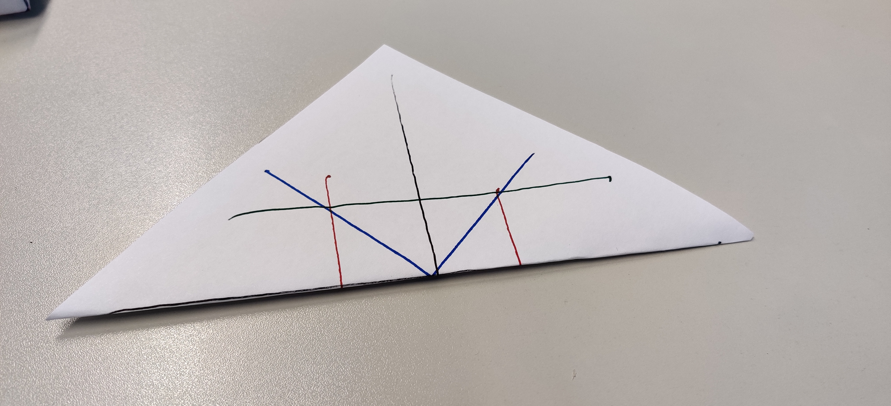

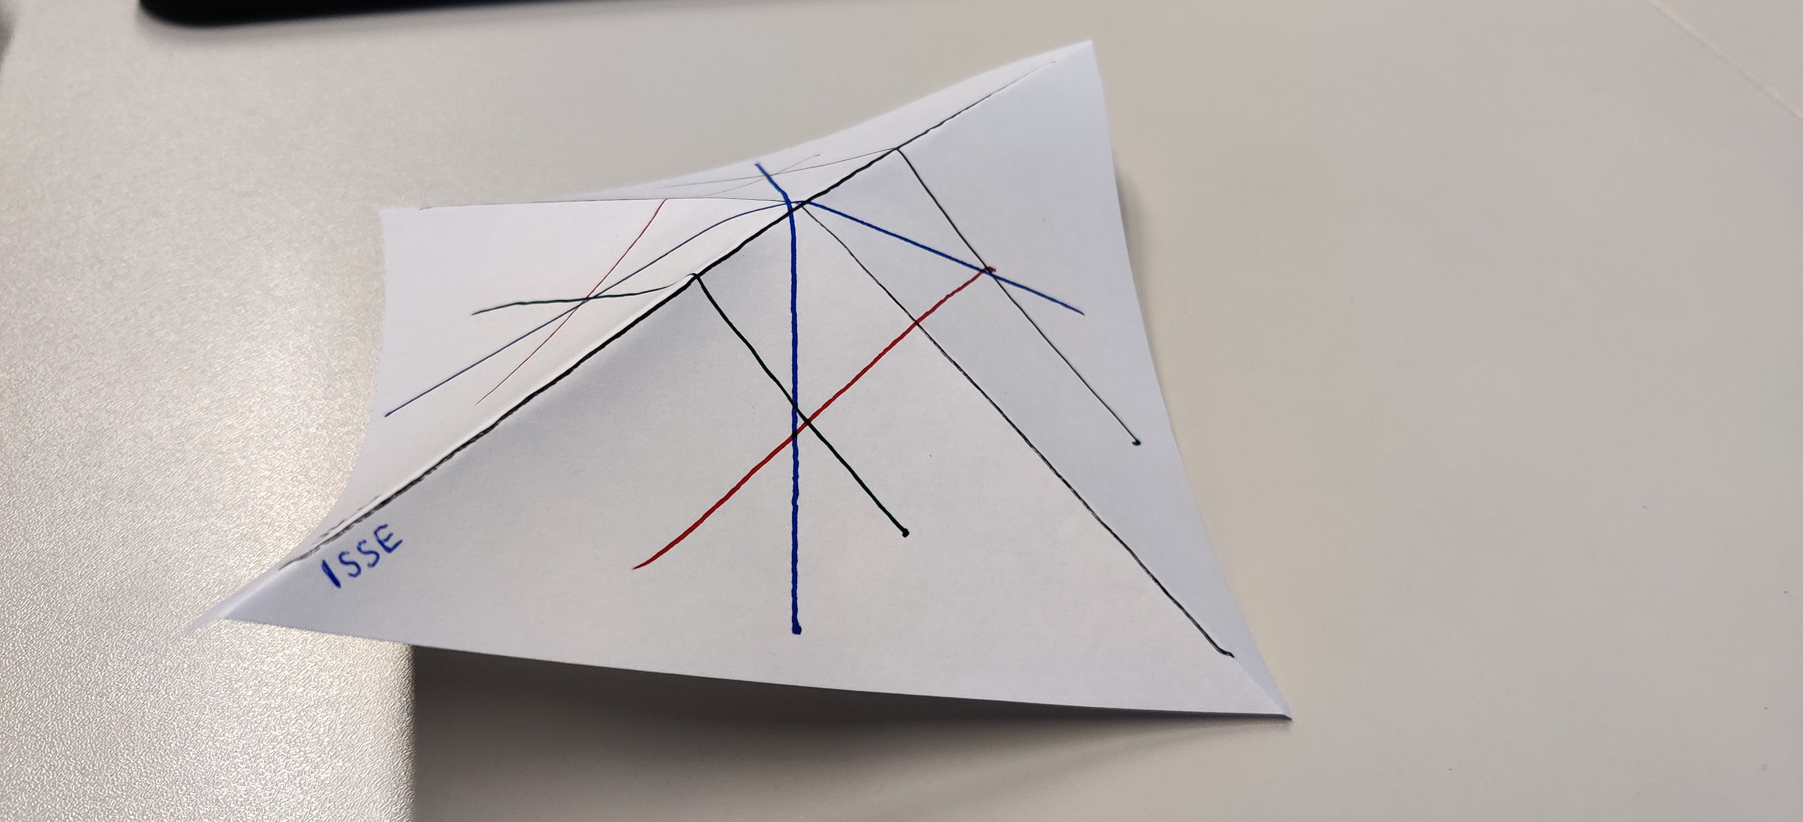

## STEP 2

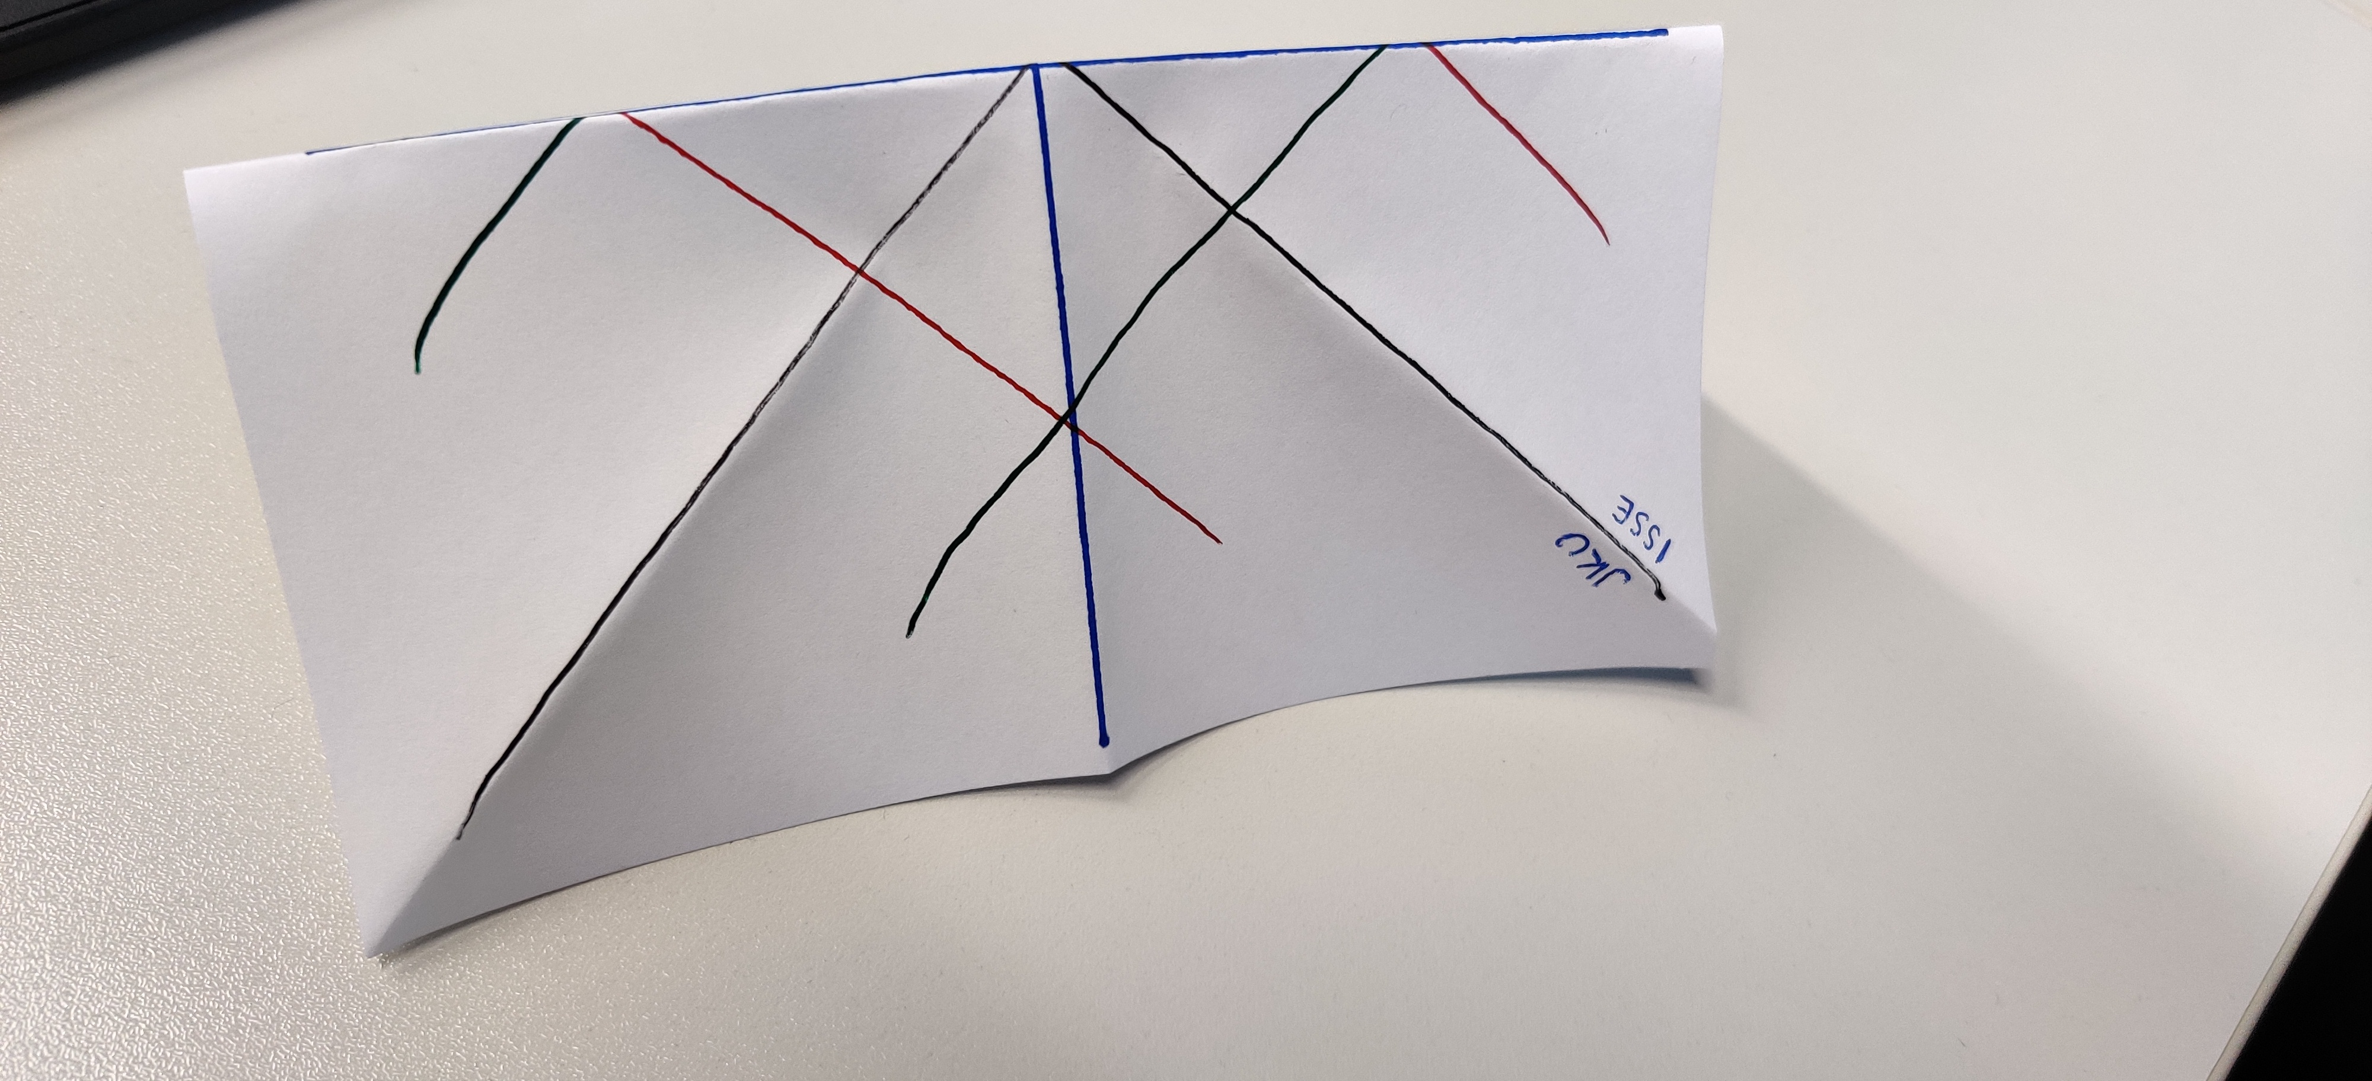

Repeat the steps from STEP 1, but this time fold along the second color (+ Pattern). This drawing has blue lines for this step.

Then turn the paper around and fold the corners towards the center (Intersection of first two line colors).

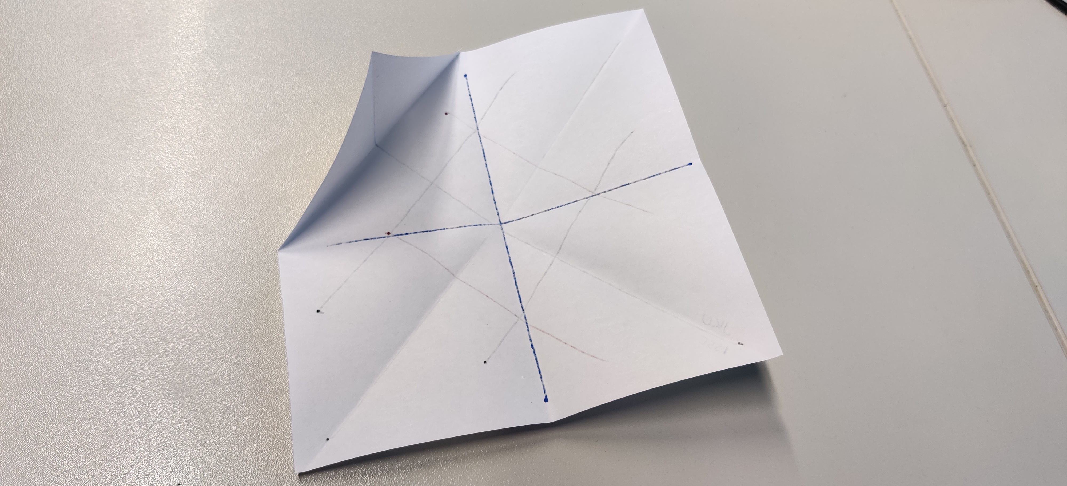

Repeat this for all four corners and leave the paper in this position.

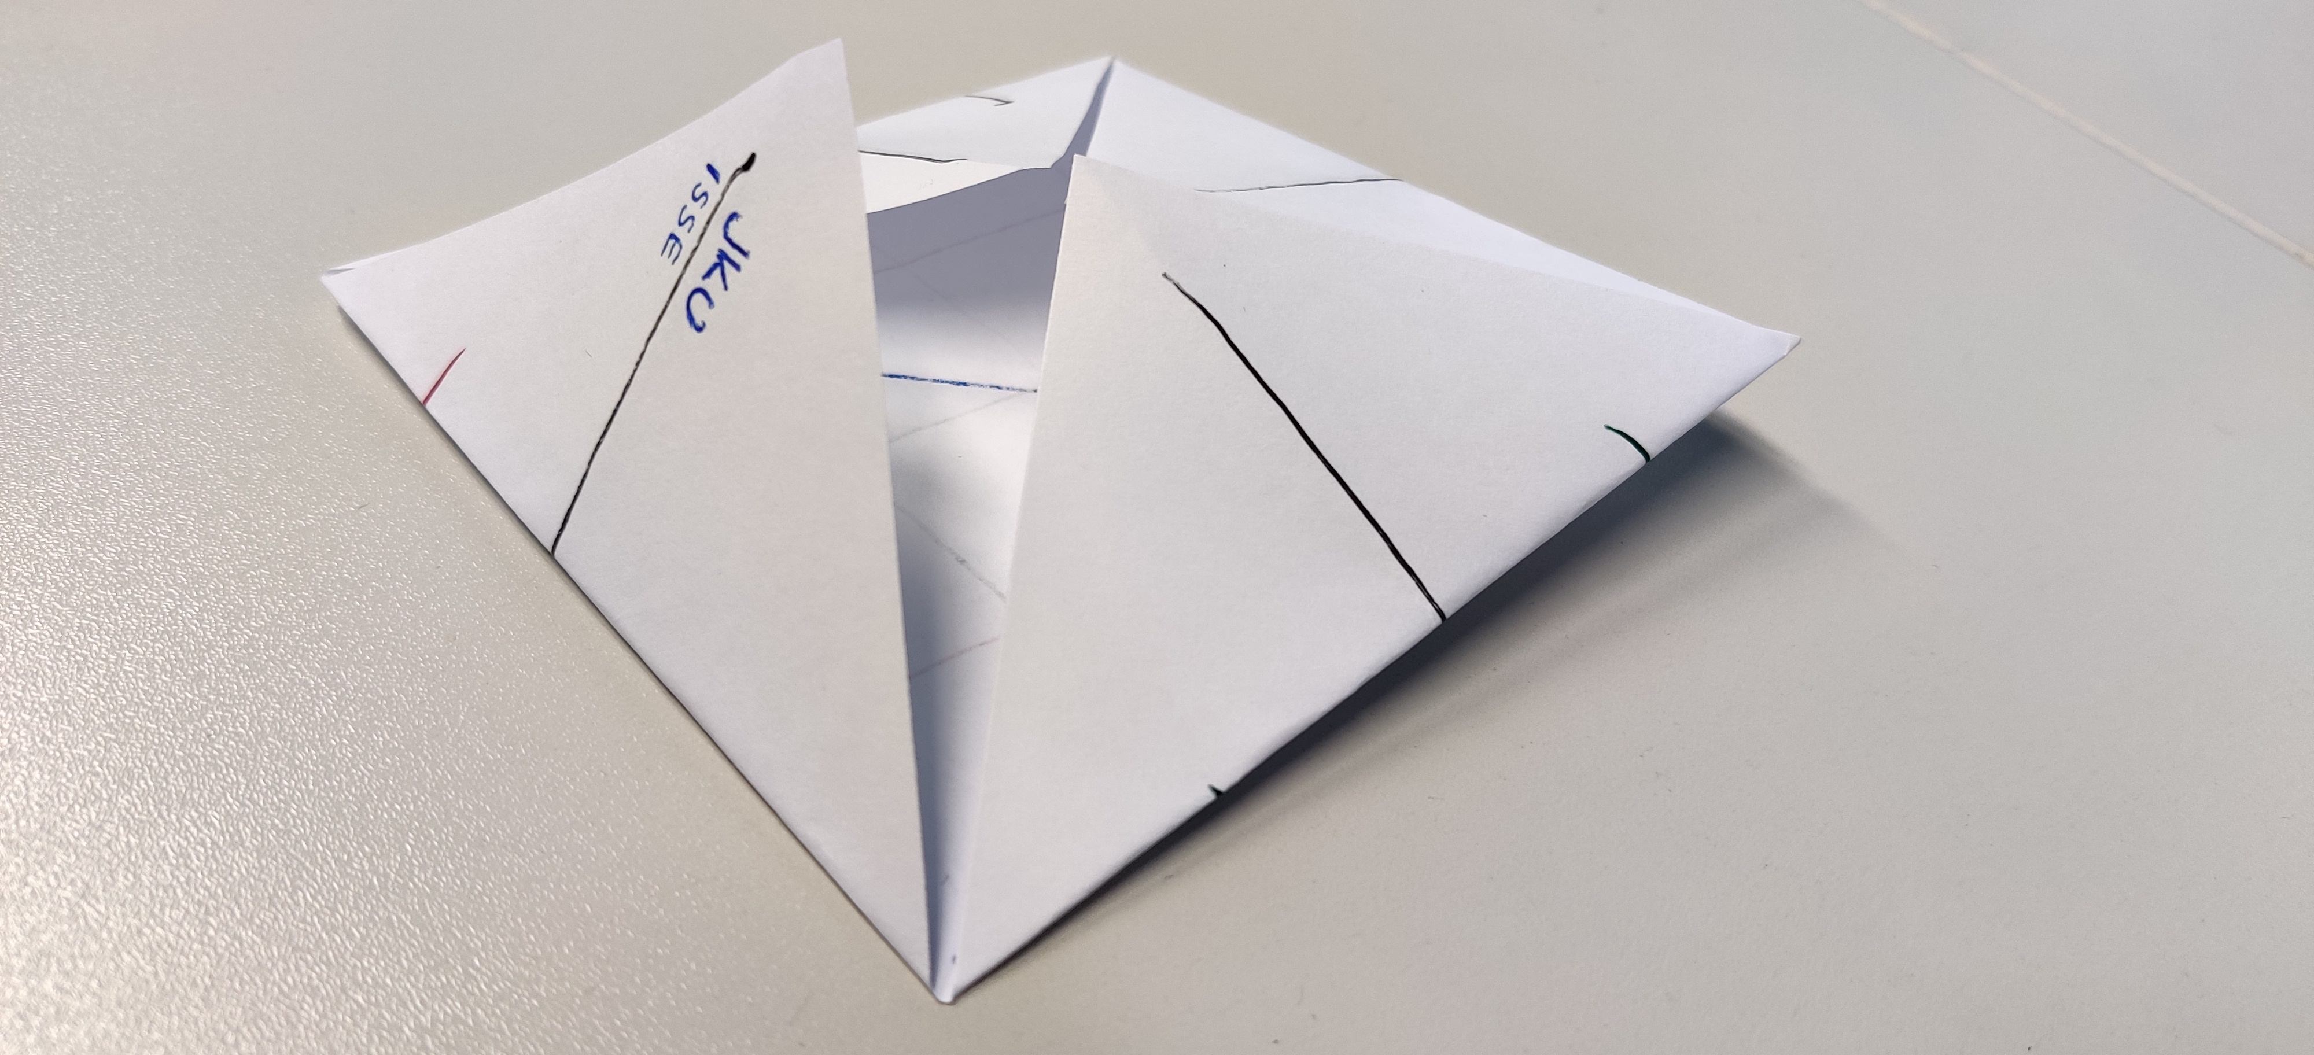

### STEP 3

Fold along the lines drawn in your third color (Diagonals). In this case they are green. The result should look something like this:

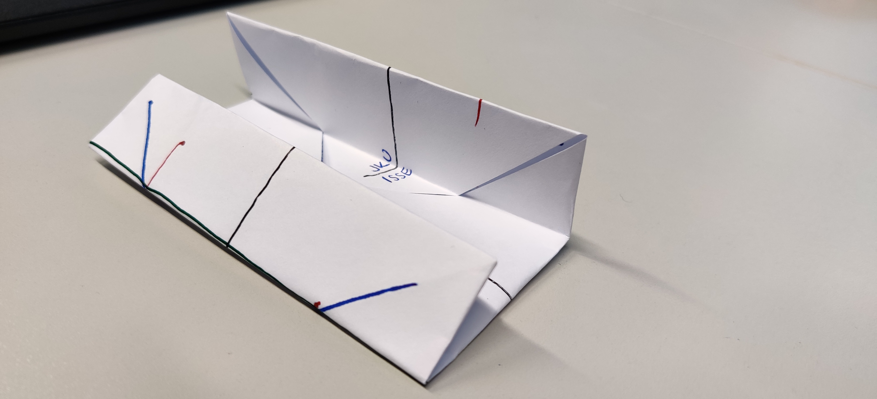

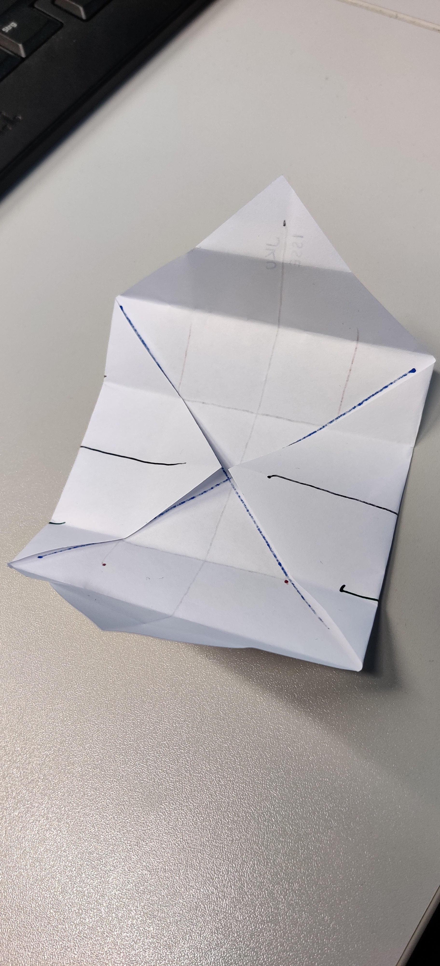Then, open the paper along the side you just folded. The result should look something like this:

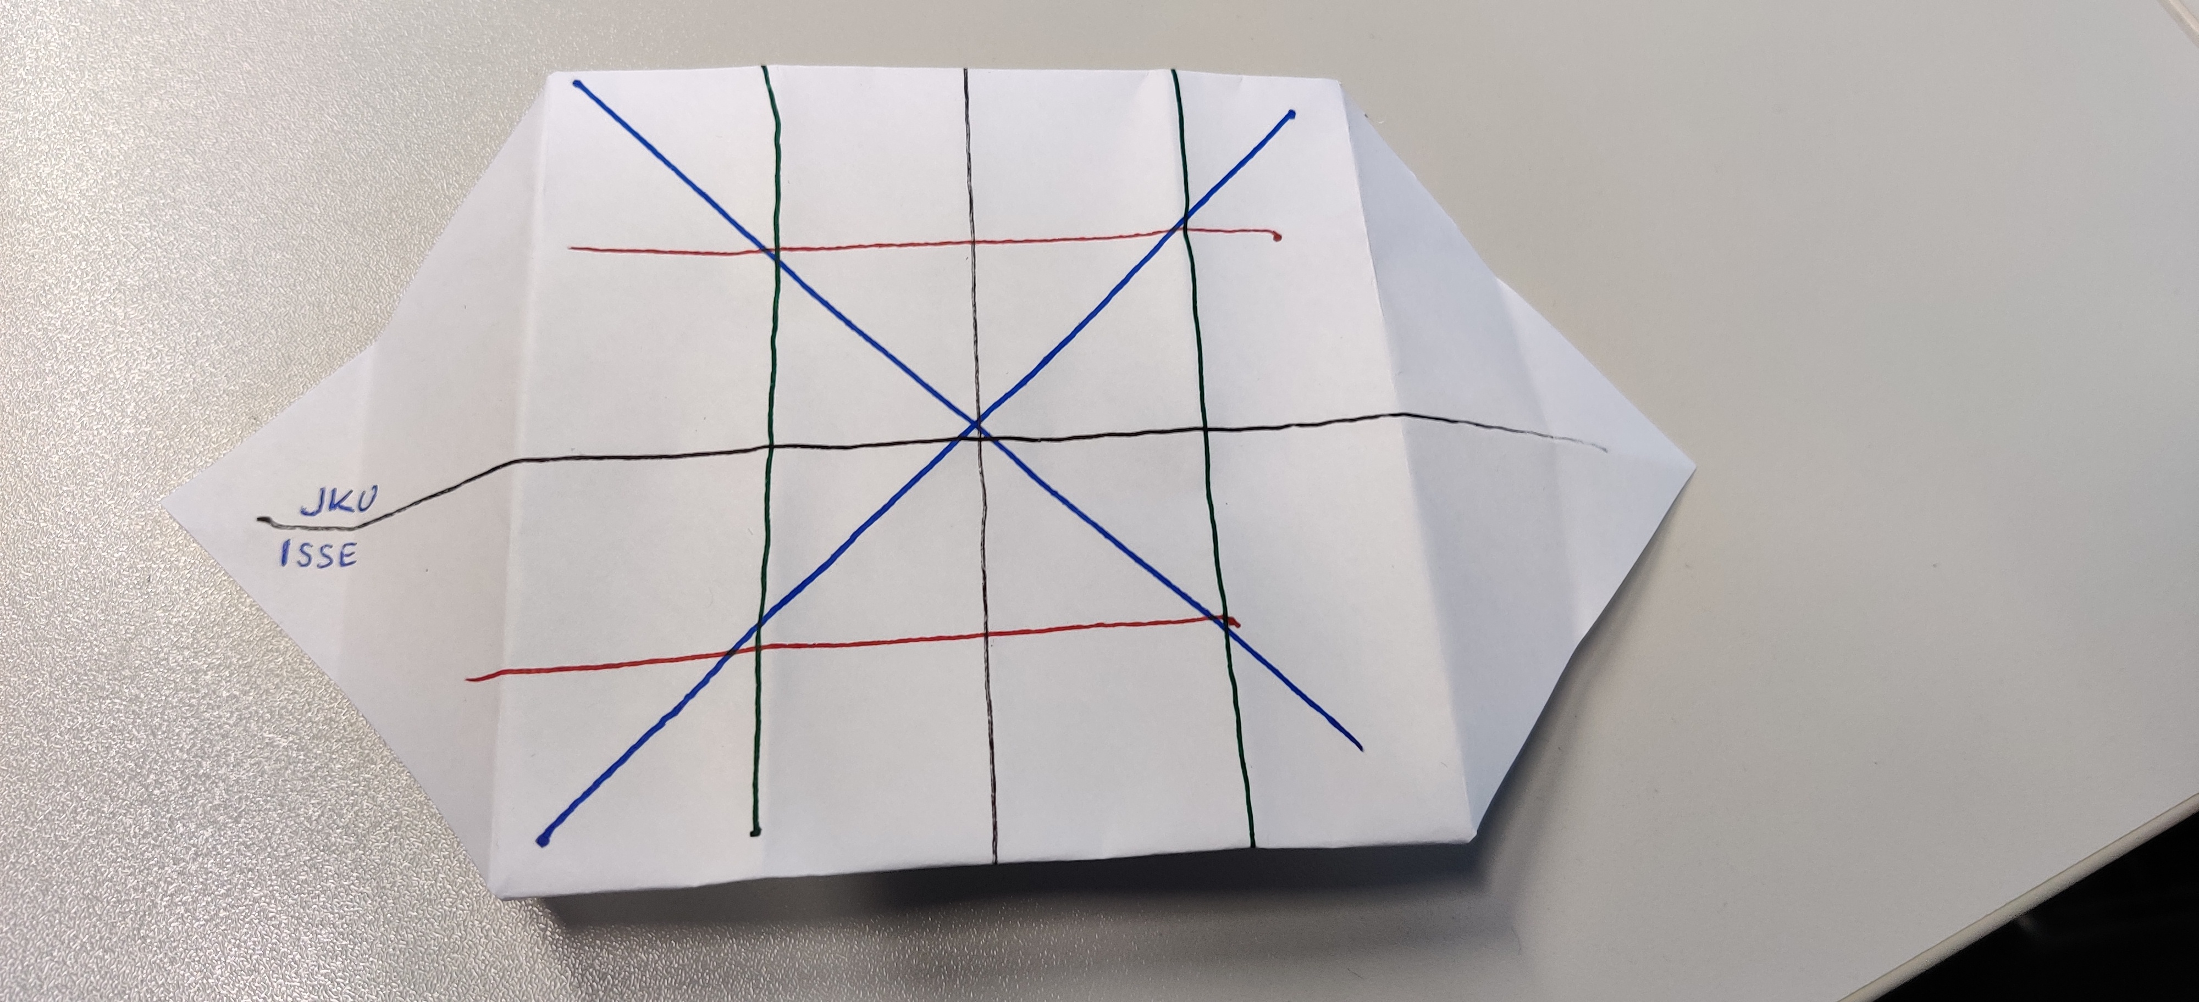

### STEP 4:

Fold the paper along the fourth color you chose (Diagonals). In this picture the red lines were chosen as the last color. Then open the paper at those edges at a 90 degree angle.

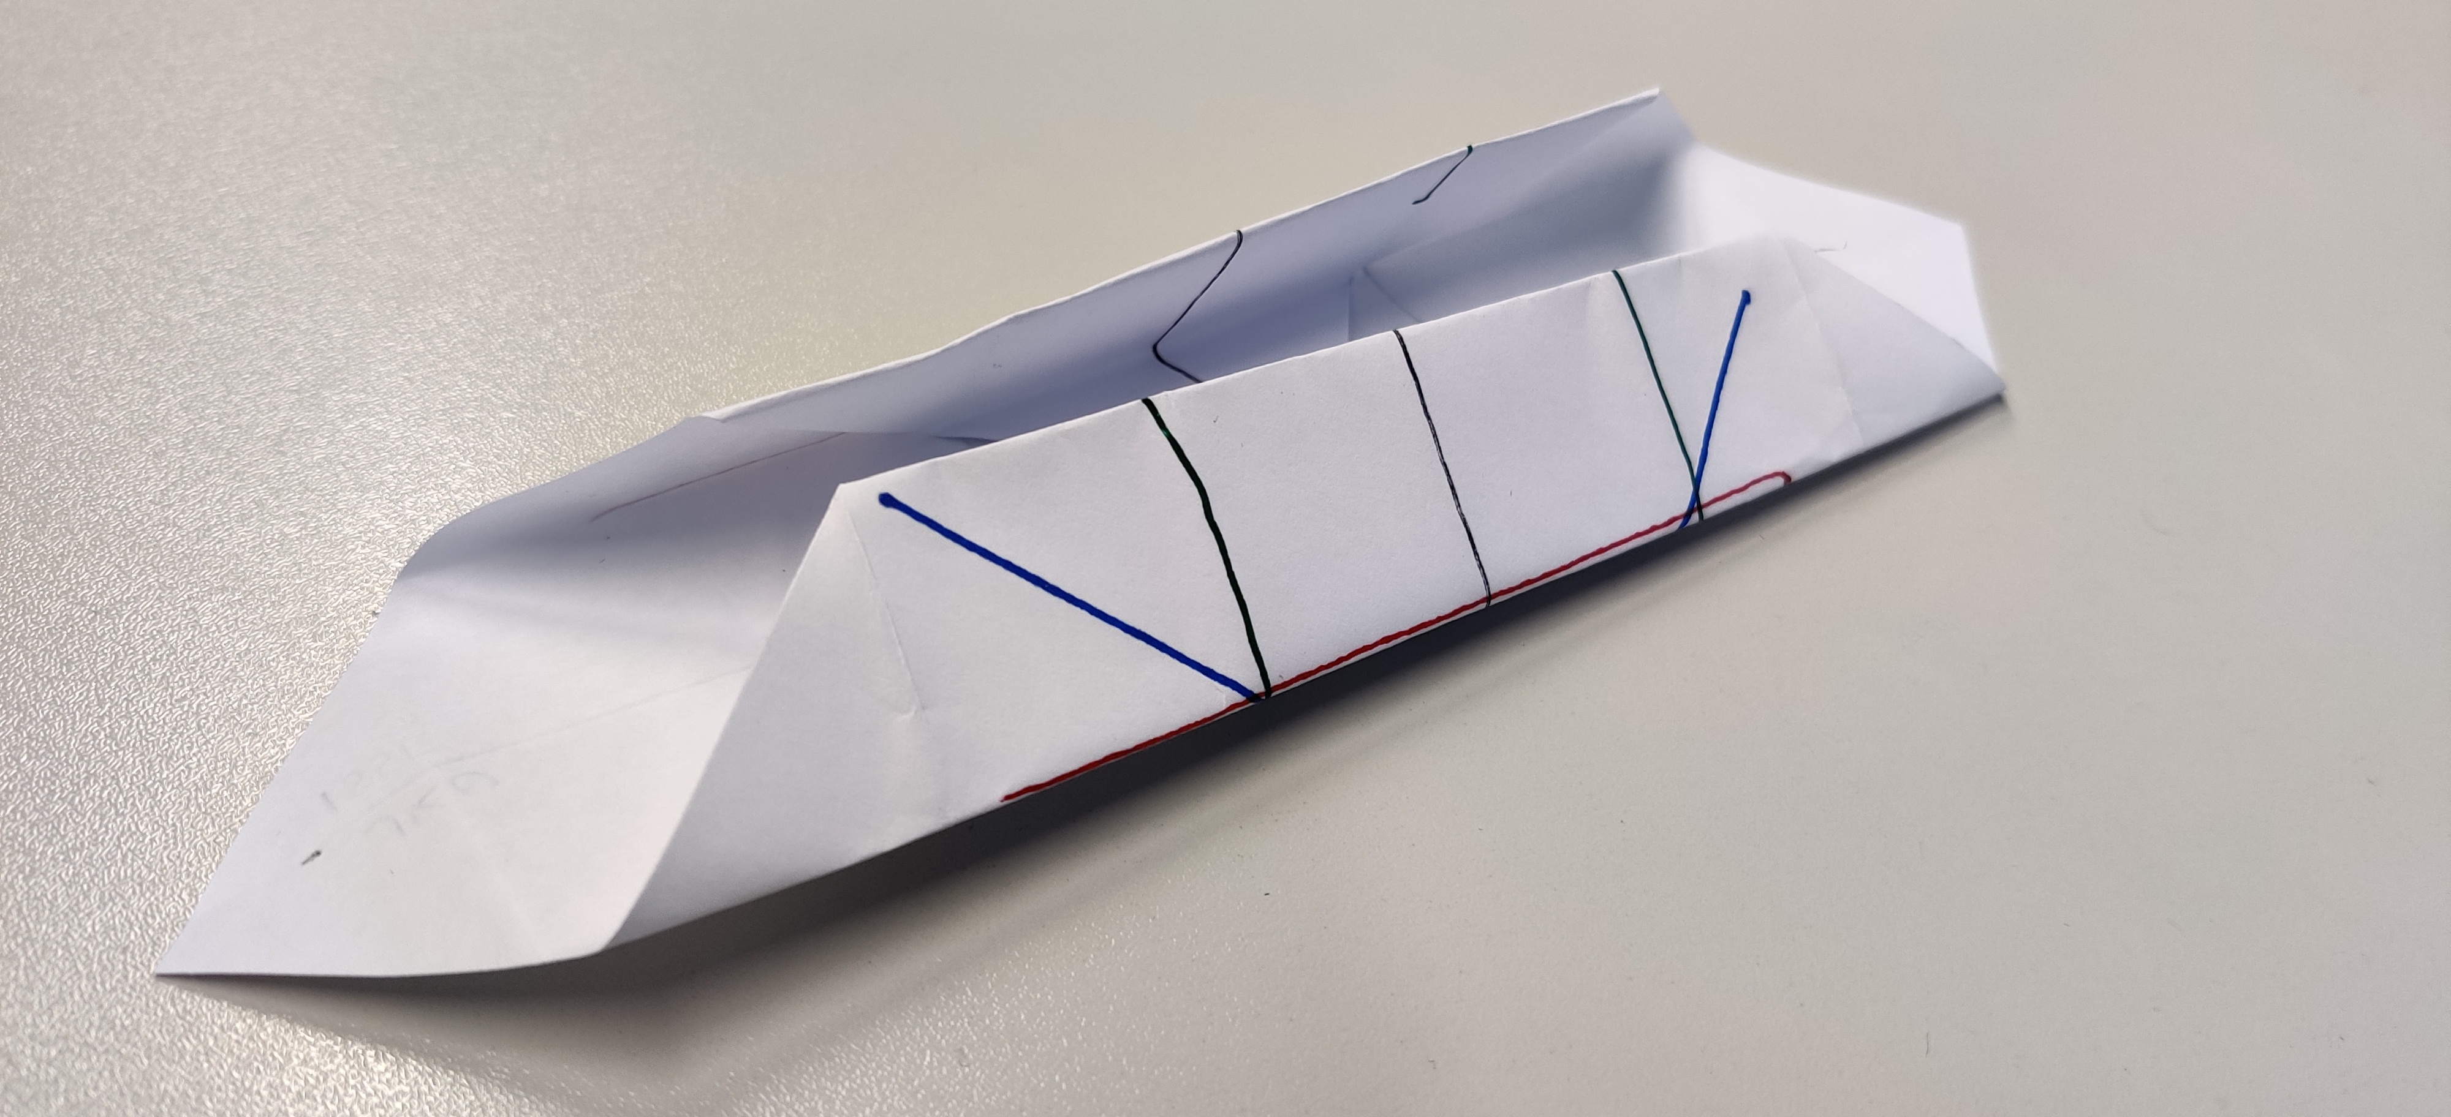

Now comes the tricky part. On the sides, where the corners can be seen, you need to pull up the corners along the lines used for STEP 3 and press with your finger on the crease above the line. Take a look at this picture for a better understanding:

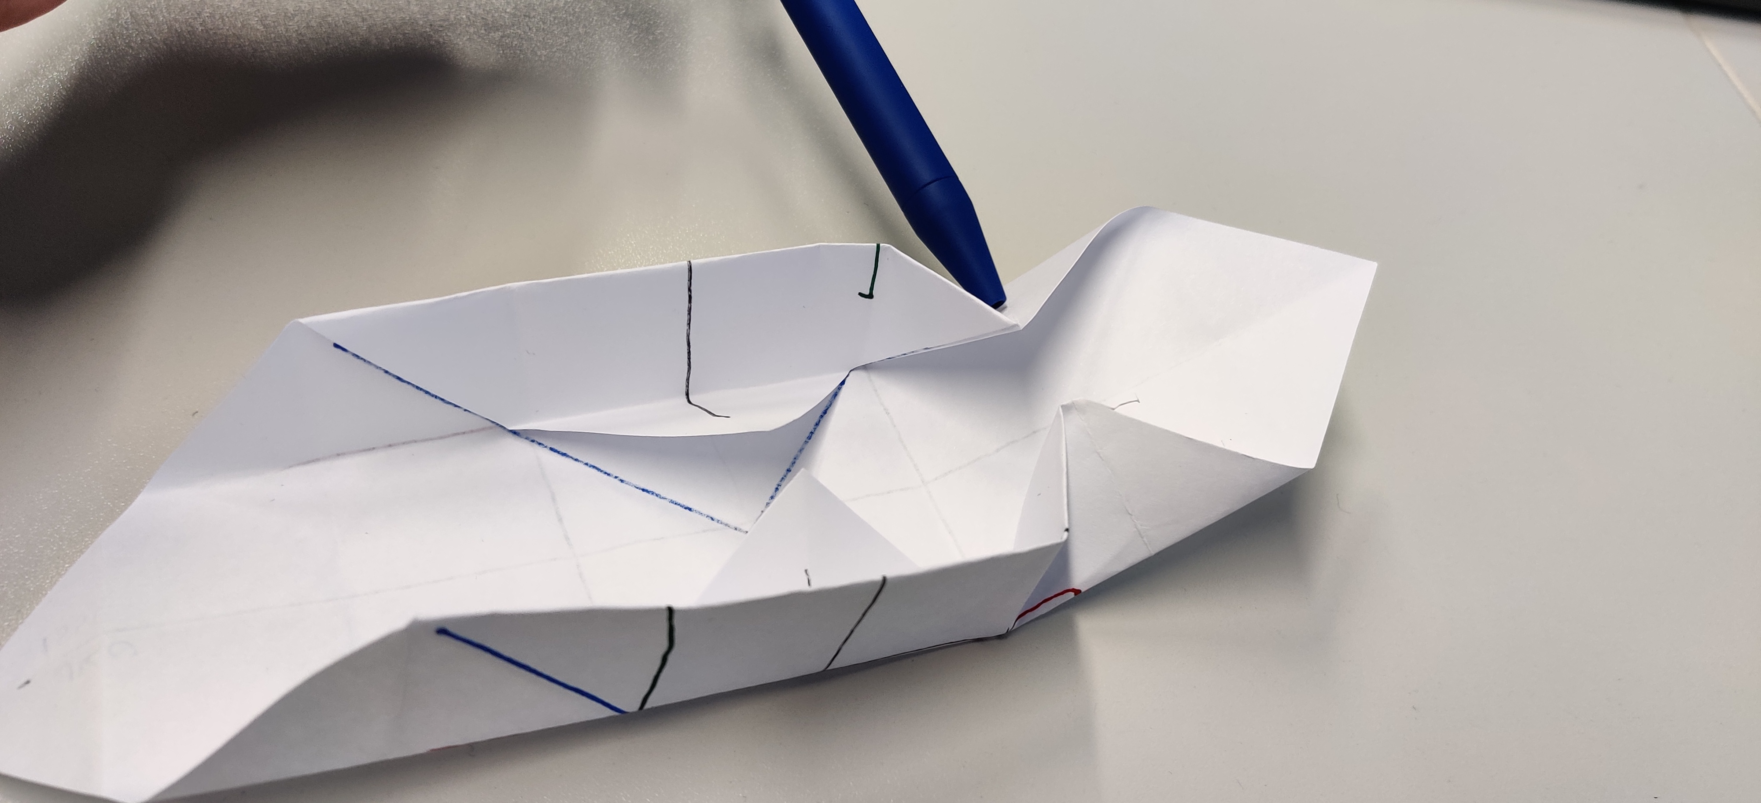

Then fold the top edge at the same height as the folds from STEP 4 along the newly created edge. Finally, push the crease closest to the corner into the center, where it was at the end of STEP 2:

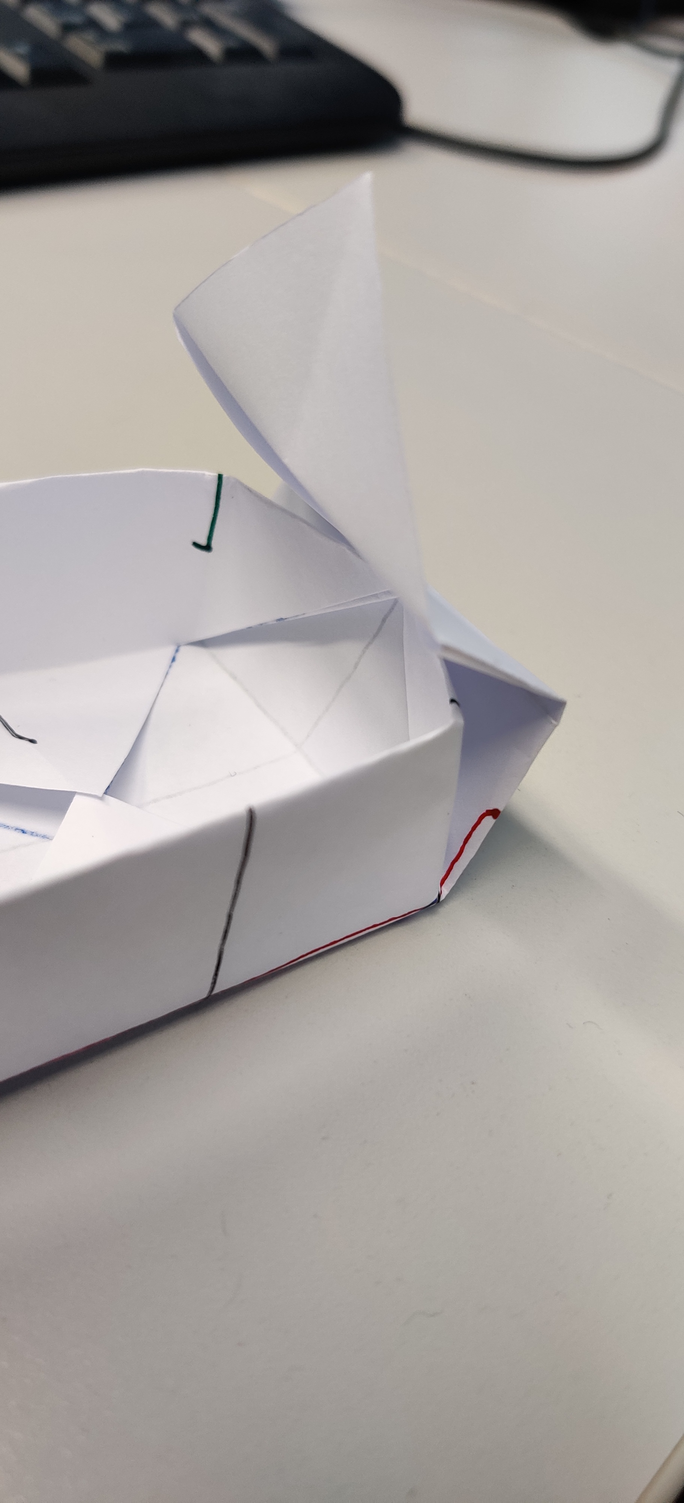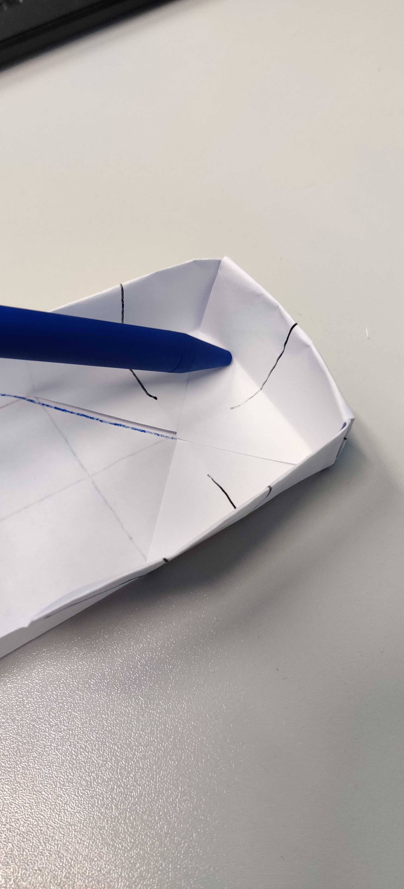

To finish the box, repeat this step for the other side and you are ready to go!

